PROBLEM-SOLVING REPORT
1.FINDING LEAP YEAR OR NOT:
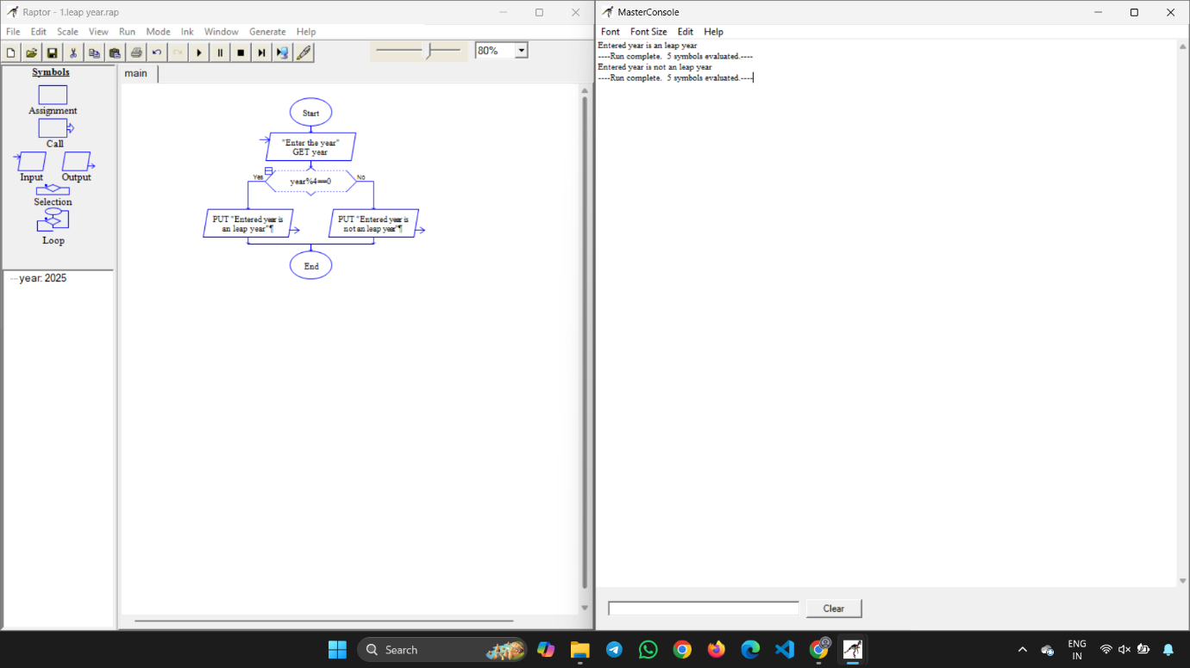

2.GREATEST OF TWO NUMBERS:

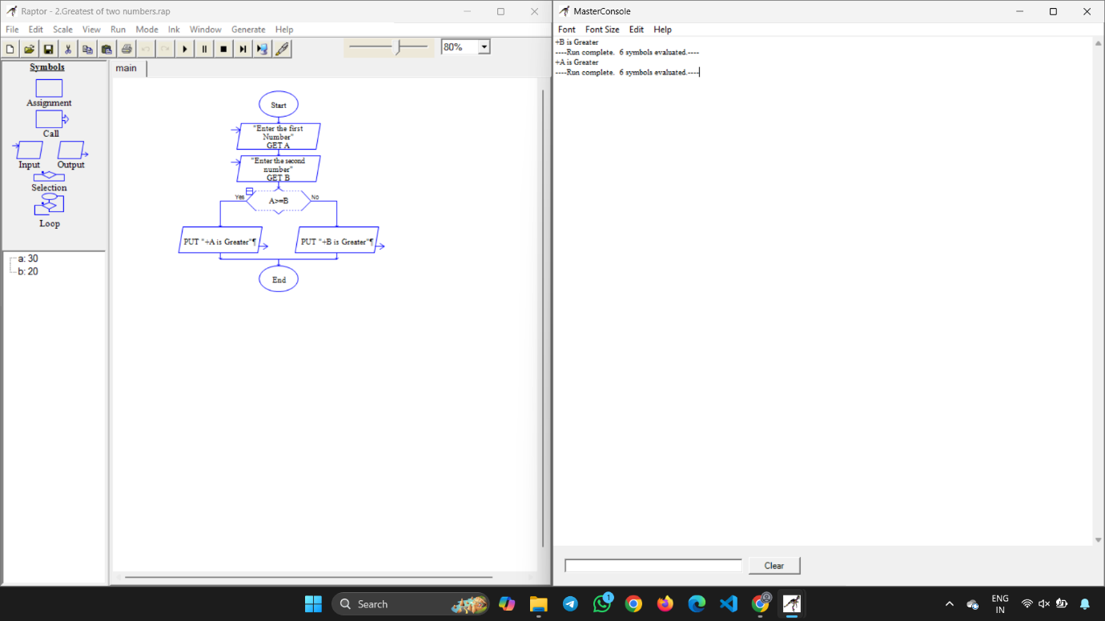

3.GREATEST OF THREE NUMBERS:

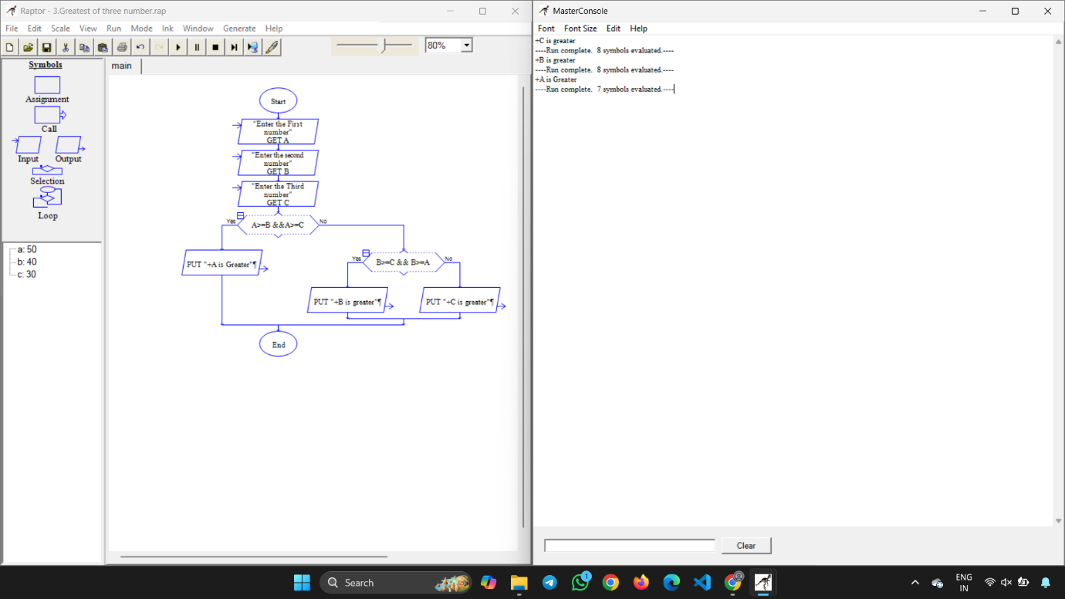

4.MOVIE REVIEW:

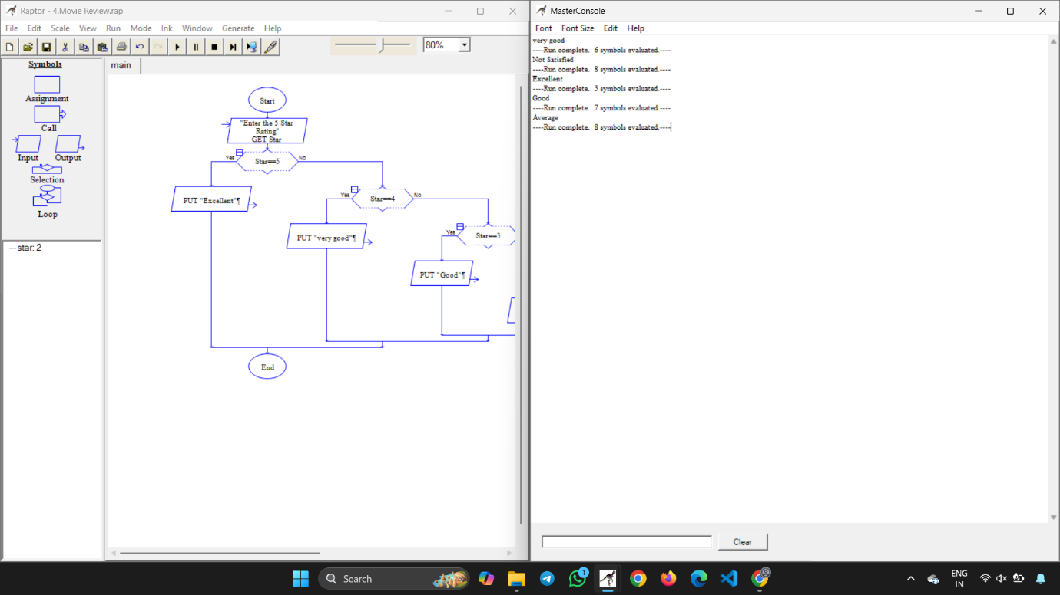

5.EB CURRENT CALCULATION:

